K:\AVON\AVON POCHOD 2012\AVON Pochod proti rakovině prsu 2012\Logo\avon proti rakovine 2012 CZ sirka.jpg

**Press release – 11June 2012**

*17 thousand visitors were walking for happy endings and hopeful beginnings through Prague on 9th June. This year’s Avon Walk for Breast Cancer broke all the records.*

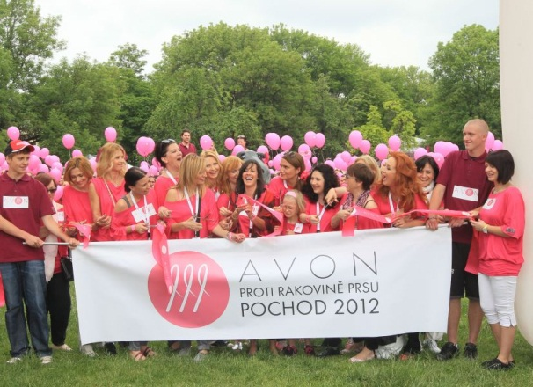“We are delighted that every year we succeed in raising the bar,” says Alena Pytlíčková, Avon Cosmetics PR and Advertising Manager. “This year’s walk exceeded all our expectations. We are very grateful to be able to cooperate with fashion designer Taťána Kovaříková who designed a walk tunic which has literally become a hit and sold almost 25,000 pieces.”

The walk full of hope and optimism started at 12:00 in the Kampa Park and was organised under the auspices of Bohuslav Svoboda, Mayor of Prague. “Thousands of Czech women develop breast cancer every year. As a doctor myself whose expertise is cancer illnesses, I welcome and support this initiative; it gives strength and hope to women and contributes to prevention of this malicious illness.”

At the start, the visitors had the opportunity to meet not only the host, Roman Vojtek, or Děda Mládek Illegal Band, but especially all the project ambassadors who support the battle against this malicious illness. The walk tunic was worn by Simona Stašová, Lenka Termerová, Aňa Geislerová, Táňa Vilhelmová, Tereza Brodská, Mahulena Bočanová, Martha Issová, Monika Absolonová as well as fashion designer Taťána Kovaříková. Gábina Partyšová and Ivana Gottová, new ambassadors, greeted all visitors at the very start. The ribbon was also cut by the ‘faces’ of Avon Cosmetics, top model Daniela Peštová and actress/singer Alžbeta Stanková who brought her two-month-old daughter Betynka along. Little Betynka, as well as all participants, were not only intrigued by beautiful T-shirts but also by special rhythmic eggs which jazzed up this year’s walk.

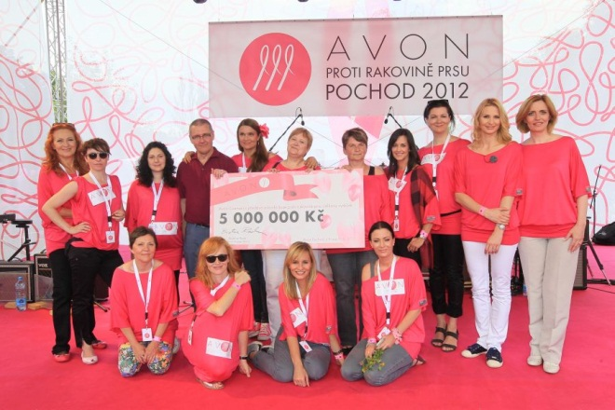

The finish of the walk was traditionally in Žluté lázně where the visitors could watch the performances of David Deyl and Chinaski. During the final performance of Anna K thousands of visitors released pink balloons as a gesture of hope and solidarity. The General Manager of Avon Cosmetics, Beatrice Radu, also handed over the cheque in the amount of 5 million Czech Crowns to the partner organisations: Mamma Help, Alliance of women with breast cancer and Associations of mammo-diagnosticians.

Avon Cosmetics, which celebrate 20 years of a fight against the malicious breast cancer this year globally, have so far donated 76 million Czech Crowns to fight this illness in the Czech Republic!