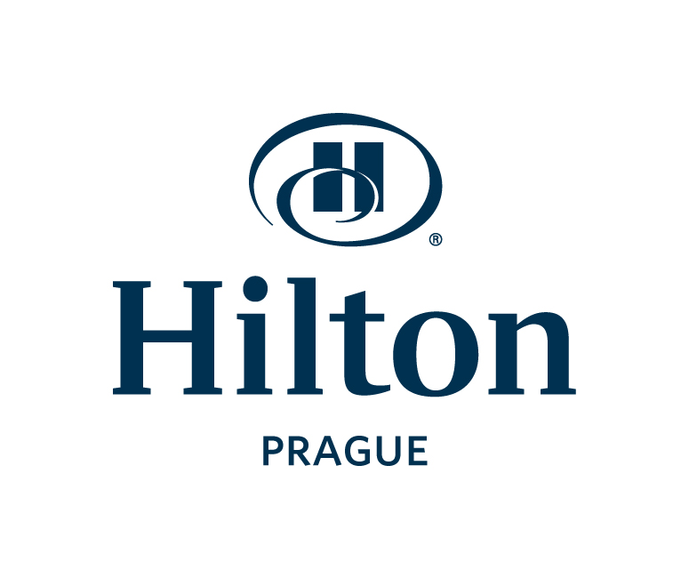

CONTACT:
Lenka Vitovská
+420 224 842 711
lenka.vitovska@hilton.com

Hilton Prague Celebrates 17 Years With Hilton Baby

PRAGUE, Czech Republic – (26 June 2012) – Hilton Prague celebrated 17th birthday of the Hilton Baby. When on the 1st of July 1995 Hilton International officially took over the operation of the Atrium Hotel in Florenc, the management of the hotel decided to choose
a first baby that was born on that day in Prague 8 (the district of Prague where the hotel is located) as the Hilton Baby and to celebrate his birthday at the Hilton Prague until he is 18. The lucky boy born in Bulovka hospital is Marek Benda, now 17 years old.

Since then, the Hilton Prague has been hosting Marek’s birthday celebration with his family every year. This year, Daniel Habersatter, Hilton Prague’s hotel manager congratulated Marek in person and Marek received a stylish smartphone from Lenka Vitovská, marketing & PR manager of Hilton hotels in Prague.
-###-

Photo 1 – from the left: Lenka Vitovská, marketing & PR manager of Hilton hotels in Prague; Marek Benda, Hilton Baby; Daniel Habersatter, hotel manager of Hilton Prague
Photo 2 – Marek Benda

About Hilton Hotels & Resorts
One of the most recognized names in the industry, Hilton Hotels & Resorts stands as the stylish, forward thinking global leader in hospitality. From inaugural balls and Hollywood award galas to business events and days to remember, Hilton is where the world makes history, closes the deal, toasts special occasions and gets away from it all. The flagship brand of Hilton Worldwide continues to build upon its legacy of innovation by developing products and services to meet the needs of tomorrow's savvy global travelers while more than 144,000 Team Members shape experiences in which every guest feels cared for, valued and respected. Today, the Hilton Hotels & Resorts portfolio includes more than 540 hotels in 78 countries and the brand remains synonymous with "hotel." Access the latest Hilton news at www.hiltonglobalmediacenter.com or begin your journey at www.hilton.com. Social media users can engage with Hilton at www.twitter.com/hiltononline, www.facebook.com/hilton and www.youtube.com/hilton. Hilton Hotels & Resorts is one of Hilton Worldwide’s ten market-leading brands.

