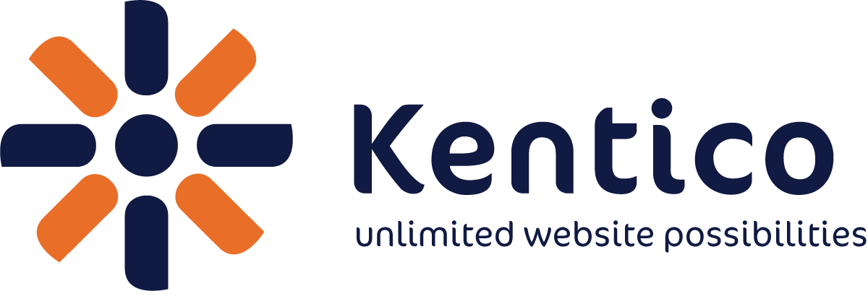 PRESS RELEASE

Media Contact:

Eric C. Webb
Kentico Software
Phone: +1-603-336 6020
E-mail: eric.webb@kentico.com

FOR IMMEDIATE RELEASE

Kentico Software Announces Kentico CMS 7 Release Candidate

Nashua, New Hampshire, USA, July 03, 2012 – Kentico Software (http://www.kentico.com), the Web content management system vendor, announced today the distribution of the Kentico CMS 7 release candidate, with General Availability expected in September, 2012. Kentico CMS 7 extends their award winning platform to include marketing automation, enhanced mobile support, advanced workflow, translation management and user experience improvements.

“Kentico CMS 7 continues to empower our worldwide customers and partners in clearly demonstrating ROI in the execution of their online marketing.” says Petr Palas, CEO and founder of Kentico Software. “Especially when combined with our recently-announced Kentico+ software-as-a-service (SaaS) offering, Kentico CMS represents a great value for any customer who requires an integrated Customer Experience Management solution.”

A key improvement to Kentico CMS 7 will be Marketing Automation that extends lead management, scoring, segmentation and e-mail marketing to include automated marketing campaigns orchestrated by Kentico EMS. Version 7 will also bring enhanced support for mobile websites, deeper integration with social networks and a built-in Salesforce.com Connector, allowing customers to deliver customer-centric marketing across multiple channels.

“Our UX efforts on Kentico CMS 7 have been focused on making content administrators, marketers, developers and IT departments more productive,” says Martin Hejtmanek, CTO at Kentico Software. “Kentico CMS 7 introduces enhancements like On-site editing, Visual Workflow designers and Translation managements all specifically designed to increase productivity”

For more details and to download Kentico CMS 7, go to: http://www.kentico.com/kentico7

The final version will be launched on September 17, 2012 at the annual Kentico Connection conference in Denver, Colorado with more information here: http://denver.kentico.com

About Kentico CMS

Kentico CMS is an enterprise Web Content Management System and Customer Experience Management System that provides a complete set of features for building websites, intranets, community sites and e-commerce solutions on the Microsoft ASP.NET platform on premise or in the cloud. It supports mobile websites, SEO, document management, online marketing tools, multilingual websites, multisite management and it ships with 40 modules, 340 configurable Web parts and source code available.

Kentico CMS customers can expect a highly flexible platform with a uniquely easy-to-use user interface. It’s currently used by more than 12,000 websites in 87 countries. The clients include Microsoft, Guinness, McDonald's, Vodafone, O2, Orange, Brussels Airlines, Mazda, Ford, Subaru, Isuzu, Samsung, Gibson, ESPN, DKNY, Abbott Labs, Medibank, Ireland.ie and others.

About Kentico Software

Kentico Software (www.kentico.com) helps clients create successful dynamic websites, intranets, community sites and e-commerce solutions using Kentico CMS for ASP.NET. It's committed to deliver a full-featured, enterprise-class, stable and scalable Web Content Management solution on the Microsoft .NET platform. Founded in 2004, Kentico is headquartered in the Czech Republic and has offices in the United States (Nashua, NH and Seattle, WA), United Kingdom (Reading) and Sydney (Australia). Since its inception, Kentico has continued to rapidly expand the Kentico CMS user base worldwide. Its partner network consists of 1,200 partners in 80+ countries. Kentico Software is a Microsoft Gold Certified Partner. In 2010, Kentico was named the fastest growing technology company in the Czech Republic in the Deloitte Technology FAST 50 awards.

www.kentico.com

