Prague, 20 September 2012

# KPMG Czech Republic: Fergus Cunningham

# appointed Partner in Audit

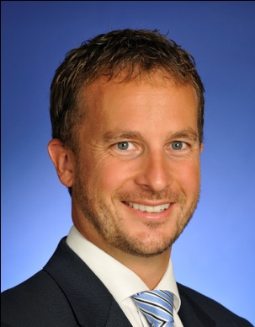**Fergus Cunningham** has been appointed as a Partner in the Audit department of KPMG in the Czech Republic. In his new role he will continue to act as a primary contact point for new and existing foreign investors. In addition, he will support the Management Consulting department in their shared service centre implementation and optimisation projects. He currently provides audit and related services to more than 100 local and international businesses in the diversified industrials, consumer markets (FMCG) and automotive sectors.

Fergus Cunningham joined KPMG in the Czech Republic in 2002 after having worked for four years at KPMG in Australia. In 2004 he was promoted to Manager and in 2007 to Senior Manager, which included responsibility for leading one of KPMG Czech Republic’s audit groups and playing a key role in its budgeting, HR management and internal change management projects, as well as managing the company’s office in Brno.

In 2009 he was promoted to Director, with ultimate responsibility for overseeing the implementation of audit strategy and signing off on statutory financial statements and group consolidated reporting packages under IFRS, US GAAP and Czech accounting frameworks.

Since 2011 Fergus has been the head of KPMG Czech Republic’s diversified industrial services sector.

Fergus graduated from the University of Tasmania in 1997. He is a member of the Institute of Chartered Accountants in Australia and an Accredited Mediator.

He likes spending time travelling with his wife and daughter, bike riding, cooking, and enjoying the company of good friends.

Prague, 20 September 2012

**– THE END –**

|  |  |  |
| --- | --- | --- |
| **Contact us** | | |
| Kateřina Konečná  Marketing and Communications Manager  **KPMG Česká republika**  **T:** 222 123 256  E: [kkonecna@kpmg.cz](mailto:kkonecna@kpmg.cz)  [www.kpmg.cz](http://www.kpmg.cz) | Lucie Neubergová  Account Manager  **Native PR**  **T:** 731 615 033  E: [lucie.neubergova@nativepr.cz](mailto:lucie.neubergova@nativepr.cz)  [www.nativepr.cz](http://www.nativepr.cz) |

*KPMG has been active in the Czech Republic since 1990, when the first office in Prague was opened. Currently, KPMG Czech Republic employs 760 people, with offices in Prague, Brno, České Budějovice, Liberec and Ostrava. KPMG Czech Republic provides Audit, Tax, Advisory and Legal services. Of our 620 professionals, 29 are partners, 27 certified auditors, 96 certified accountants and 65 tax advisors. In KPMG Czech Republic, a total of 22 qualified foreign practitioners are employed.*

*KPMG is a global network of professional firms providing Audit, Tax and Advisory services. We operate in 152 countries and have 145,000 people working in member firms around the world. The independent member firms of the KPMG network are affiliated with KPMG International Cooperative (“KPMG International”), a Swiss entity. Each KPMG firm is a legally distinct and separate entity and describes itself as such.*