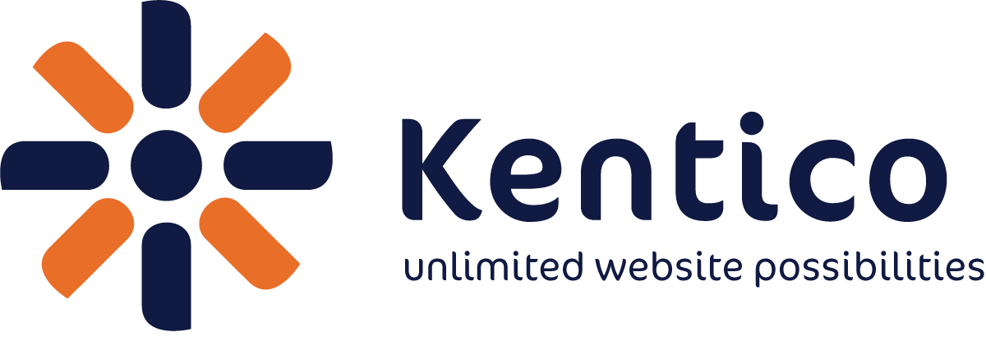 PRESS RELEASE

Media Contact:

James Hart
Kentico Software
Phone: +420 724 329 720
E-mail: jamesh@kentico.com

FOR IMMEDIATE RELEASE

Kentico Launches New Online Marketing Competency

Wokingham, Berkshire, UK, October 25, 2012 – Kentico Software (http://www.kentico.com), the Web Content and Customer Experience Management vendor, today introduced the Kentico Online Marketing Competency and awarded Kentico Gold Certified Partners NetConstruct and Pull Digital with first recognition. This competency enables customers to recognize Kentico partners based on their expertise in delivering Kentico EMS websites.

“Any Kentico Gold Certified Partner who completes two or more Kentico EMS (Enterprise Marketing Solution) implementations, leveraging its advanced marketing features, and successfully passes the Kentico Online Marketing knowledge test with a minimum score of 80% is eligible to receive this recognition of their experience,” said Lenka Navratilova, Partner Program Manager at Kentico Software. “Both NetConstruct and Pull Digital are well-established Kentico Gold Partners and the Online Marketing Competency recognition proves their proficiency in creating Kentico EMS websites and distinguishes their skills and experiences as being superior in enterprise Web development with Kentico.”

Kentico Online Marketing Competency is awarded to Kentico Gold Certified Partners who not only pass the Kentico Online Marketing knowledge test, but who show expertise in creating websites using Kentico EMS, making use of its many enterprise marketing tools, such as Marketing Automation, Email marketing, Contact Management and Segmentation, Lead scoring, Analytics, and Reporting.

Pull Digital, a leading online marketing agency based in the UK, has been a Kentico partner for over 3 years with over 30 sites completed.

“We see Kentico EMS as an important evolution for Kentico CMS and it will enhance our online marketing offering considerably,” commented Manoj Shah, Digital Services Director of Pull Digital. “It is changing the way Pull and its clients see and use websites, utilizing its improved tracking and intelligence to increase ROI. Several of our clients are now on board with Kentico EMS too, and we are looking forward to rolling it out over the coming months.”

NetConstruct, a UK-based Full Service Digital Agency, has been a Kentico partner for 4 years with 75 sites completed.

“NetConstruct sees Kentico EMS as a vital tool for today’s marketing professionals who want genuine marketing intelligence and automation from their website platform rather than just good content management,” said Jonathan Healey, Development Director at NetConstruct.

Pull Digital case study on Kentico EMS: http://bit.ly/RhZo3T
More information about Pull digital and other real world case studies are available on request from www.pulldigital.com

NetConstruct case study on Kentico EMS: http://bit.ly/Vyqidc
More information about NetConstruct: http://www.kentico.com/Partners/NetConstruct

More information about Kentico EMS is available at: http://www.kentico.com/Product/For-Marketers

There is a LinkedIn group dedicated to Kentico Online Marketing and EMS: http://www.linkedin.com/groups?home=&gid=4679569&trk=anet_ug_hm

More information about Kentico EMS is available at: http://www.kentico.com/Product/For-Marketers

About Kentico CMS

Kentico CMS is an enterprise Web Content Management System and Customer Experience Management System that provides a complete set of features for building websites, intranets, community sites and e-commerce solutions on the Microsoft ASP.NET platform on premise or in the cloud. It supports mobile websites, SEO, document management, online marketing tools, multilingual websites, multisite management and it ships with 70 modules, 400 configurable Web parts and source code available.

Kentico CMS customers can expect a highly flexible platform with a uniquely easy-to-use user interface. It’s currently used by more than 15,000 websites in 87 countries. The clients include Microsoft, Guinness, Chiquita, Vodafone, O2, Orange, Brussels Airlines, Mazda, Ford, Subaru, Isuzu, Samsung, Gibson, ESPN, DKNY, Abbott Labs, Medibank, Ireland.ie and others.

About Kentico Software

Kentico Software (www.kentico.com) helps clients create successful dynamic websites, intranets, community sites and
e-commerce solutions using Kentico CMS for ASP.NET. It's committed to deliver a full-featured, enterprise-class, stable and scalable Web Content Management solution on the Microsoft .NET platform. Founded in 2004, Kentico is headquartered in the Czech Republic and has offices in the United States (Nashua, NH and Seattle, WA), United Kingdom (Reading) and Sydney (Australia). Since its inception, Kentico has continued to rapidly expand the Kentico CMS user base worldwide. Its partner network consists of 1,200 partners in 80+ countries. Kentico Software is a Microsoft Gold Certified Partner. In 2010, Kentico was named the fastest growing technology company in the Czech Republic in the Deloitte Technology FAST 50 awards. In 2012, Kentico Software was named global Microsoft Partner of the Year Finalist in the ISV/Software Solutions Industry category.

About Pull Digital

Pull Digital is a full service online marketing agency delivering strategy, branding & design, website development and digital campaigns. We are 100% focused on improving our clients’ bottom line, delivering measurable results and high ROI, we call it Marketing Certainty™.

Working across B2C and B2B brands, we blend timeless communication know-how with leading technologies to transform our clients’ businesses. Pull is a Kentico Gold Partner and we have completed over fifty projects using the Kentico CMS. We are also one of the first UK agencies to deploy the Kentico EMS.

Pull Digital offers all the knowledge and experience of an international agency, without their costs. We combine traditional marketing, creativity and best practice approaches and solutions with leading edge digital marketing.

About NetConstruct

NetConstruct is a leading full-service digital agency with more than 15 years’ experience having delivered more than 2,000 projects.

From offices in London and Leeds, it takes a business consultancy approach to understanding its clients’ objectives and target outcomes. NetConstruct works closely with clients to deliver the digital solutions and campaigns that provide them with real business benefit.

All product and company names herein may be trademarks of their respective owners.

www.kentico.com

