

PRESS RELEASE Prague 07. 11. 2012

**Residential Park Baarova Awarded Two Prizes in the Real Estate Project of the Year Contest**

**Thursday, 1st November 2012 saw the Real Estate Congress with announcement of final results of the second year of the Real Estate Project of the Year 2012 contest. Residential Park Baarova, which has been developed by PASSERINVEST GROUP, scooped two prizes in this contest – an award for project executed within the area of Prague 4 and the Architects Prize.**

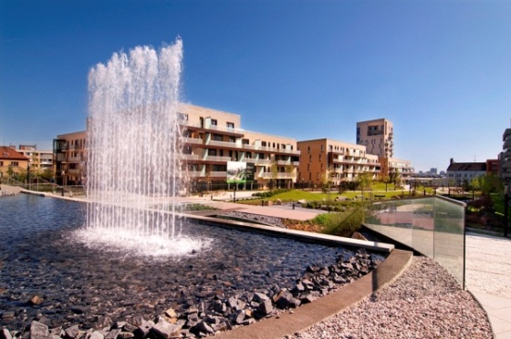 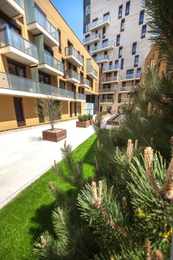 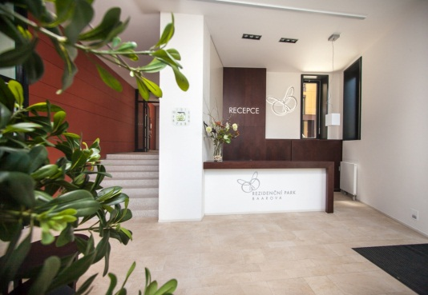

The Residential Park Baarova is situated in Michle quarter of Prague, between Baarova and Telcska streets and Baaruv Park, immediately adjacent to the BB Centre. It comprises three separate residential buildings enclosing a modern inner courtyard with a charming interior garden designated strictly for residents. Every building has separate entrances, both from the street as well as from the adjacent Barruv Park with a lovely pond and a large water fountain. Entrances to the residential area are secured by means of card system – security and privacy of residents are also supported by the non-stop main concierge and CCTV.

*“Both awards in the Real Estate Project of the Year 2012 contest are greatly appreciated by us, as we truly believe that the Residential Park Baarova is a really unique project completed within a very attractive location with excellent amenities and very good transport service. I see the awards earned as proof of my words,”* says Radim Passer, General Director of PASSERINVEST GROUP.

The **Residential Park Baarova**, completed this spring, comprises the total of 139 apartment units divided into three groups depending on fittings level – Classic, Modern I and Modern II. Options range from 2+kitchenette to 6+kitchenette apartments with balconies, terraces or small yards, cellars or garage stands. The size of these apartment varies from 50 to 170 m2 and, besides the high standard of materials and fittings used, these units attract potential owners by unusual ceiling height reaching up to 2.75 metres.

The primary designation of apartments in the Residential Par Baarova concerns sale, yet the developer has considered the increasing demand to prepare several apartment units for rent as well. Every apartment features a complete kitchen unit. Comfort of residents is further emphasized by built-in cabinets. Every apartment intended for rental is provided with one parking stand and a spacious cellar unit with ceiling height reaching up to 3.5 m.

Potential clients interested in viewings can see one completely furnished apartment and book their viewing appointment with the sales agent.

**ABOUT Passerinvest Group**

*As a purely Czech developer company,* PASSERINVEST GROUP, a.s. *is associated mainly with completion of the* ***BB Centre,*** *a large multifunctioning complex along Vyskocilova Street in Prague 4 – Michle. The complex has accommodated tens of local and international enterprises. The very beginnings of construction of this project date back to 1996. The current shape of complex comprises 15 finished buildings with the total floor space reaching almost 200 thousand m2. Up until today, the total amount of investment into construction has been equal to 11 billion Czech crowns, out of which the worth of non-profit investments amounts to 1.05 billion Czech crowns*. *The BB Centre also includes a modern and exclusive fitness and wellness Balance Club Brumlovka as well as the community centre with Christian kindergarten, a primary school and the generous Baaruv Park with water fountain.*

For more information contact:

**Mgr. Vendula Malochova**

Marketing Manager

PASSERINVEST GROUP, a.s.

Tel.: (+420) 221 582 111, fax: (+420) 222 515 521

E-mail: [vendula.malochova@passerinvest.cz](mailto:vendula.malochova@passerinvest.cz)

www.baarova.cz www.passerinvest.cz