Media Alert: Packing Tips for Shipping Christmas Gifts with FedEx

Prague, December 13, 2012
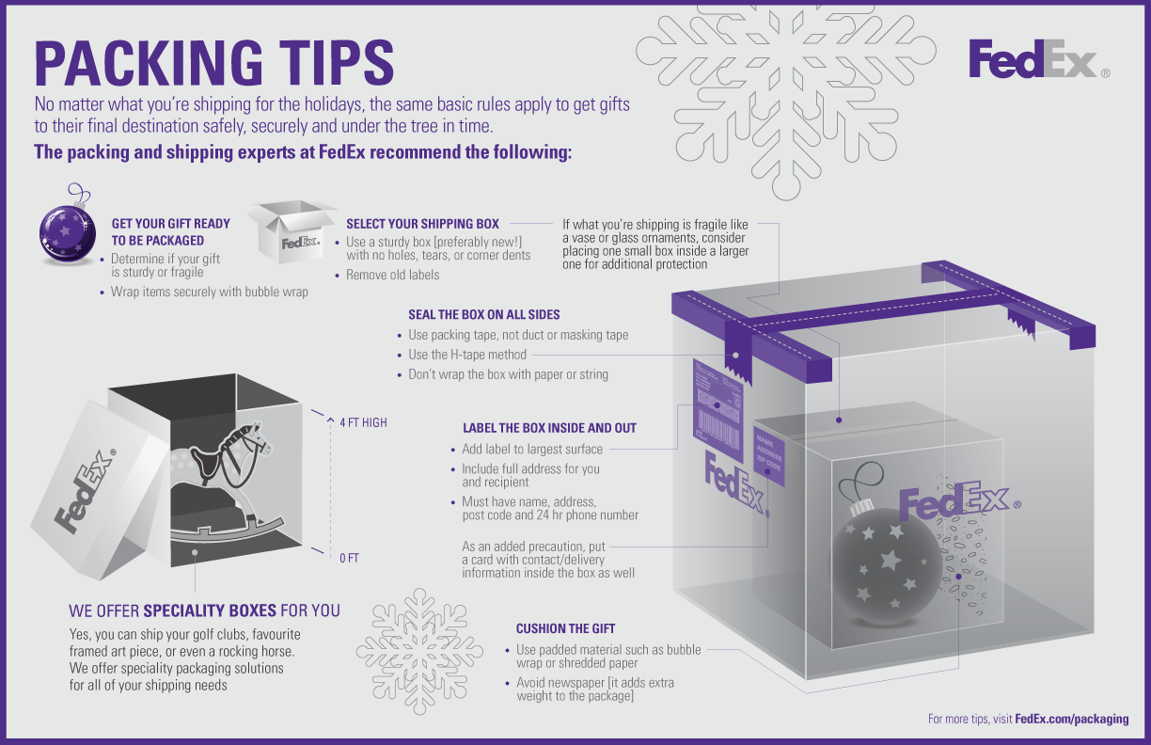 (Infographic: FedEx)

Pack your gifts like a pro: The experts at FedEx have collected a few tips on the best way to ship your Christmas gifts. Follow these helpful suggestions to ensure that your packages make the trip safely and securely.
- Choose a suitable box. It should be sturdy and not show any damage, such as dented corners or holes.
- Remove any old address labels to ensure that your package ends up at the right destination.
- Cushion the gift with lightweight material – bubble wrap or shredded paper work very well for this. Avoid newspaper- it adds extra weight to the package.
- If you are shipping fragile objects, it is a good idea to package these in a separate, smaller box inside a larger one.
- Seal the box with packing tape. Please refrain from using wrapping paper or strings.
- Place the labels with your address and the recipient’s address on the largest surface of the box. Also insert a card with both addresses in the box.

Please note: The last day to ship Christmas gifts to destinations in Europe, Asia, or North America is Friday, December 21.

About FedEx Express
FedEx Express is the world's largest express transportation company, providing fast and reliable delivery to more than 220 countries and territories worldwide. FedEx Express uses a global air-and-ground network to speed delivery of time-sensitive shipments, by a definite time and date with a money-back guarantee.

Contact: Katrin Haase, FedEx Media Relations
+496102883302
khaase@fedex.com

Ondřej Hampl, Accedo Communications Czech Republic
ondrej.hampl@accedogroup.com, +420 775132199

