Lance Knowles

DynEd International ©2013

lknowles@dyned.com

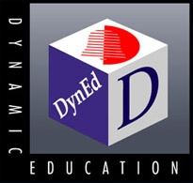

A Brain-based Approach to Skill Acquisition: RHR

Research in neuroscience underscores the importance of neuroplasticity, iconic representation, repetition, and the role of media-rich input in skill acquisition. It suggests how different pathways in the brain work together, and how sequenced, coordinated inputs facilitate long-term learning.
This paper offers a brief overview of Recursive Hierarchical Recognition (RHR), a brain-based learning theory applied to English language acquisition.
At the outset, RHR assumes that language acquisition is first and foremost a skill-acquisition process. RHR defines what this means and suggests ways to design activities to facilitate the neural processing that is involved in skill acquisition. It also presents a means for sequencing, monitoring and measuring the effectiveness of skill acquisition activities.
The Traditional Approach – Knowledge-based
In most countries, students study English in a similar way. In class, the teacher presents and explains vocabulary and grammar. There are textbooks, and there is a heavy use of text even to teach listening. The emphasis is on conscious analysis and lots of memorization. What students don’t get enough of is actual language practice, especially listening and speaking. As a result, most students don’t develop their oral skills, which is also the foundation for reading and writing.
The traditional approach is knowledge-based and inefficient.
The Demands of Fluency
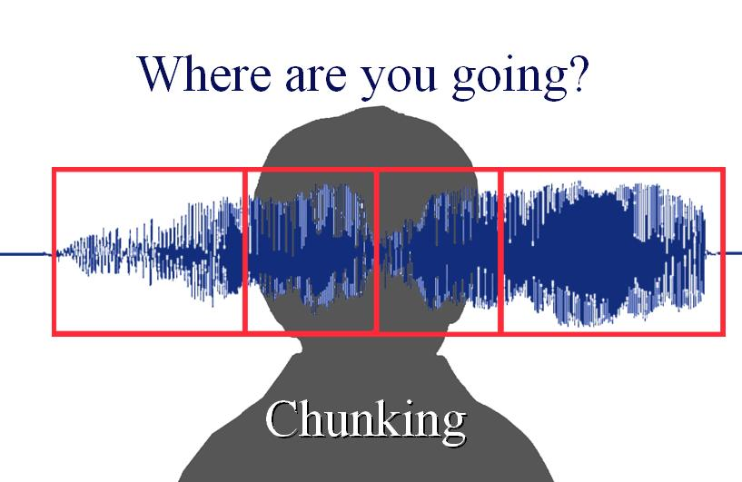
What is missing in the traditional approach is the practice necessary to develop automaticity, the skill to automatically process and chunk language, where chunking means to recognize and process groups of words rather than discrete items.
The working memory required to store and process spoken language is limited, so if chunks are too small and too many, spoken language input cannot be processed quickly enough and fluency is limited.
RHR systematically develops the language chunking skill. Teaching discrete words is avoided. Instead lexical items are presented in phrases, such as ‘a book’, ‘a red book’, ‘a green book’ ‘open the red book’, etc. Presenting vocabulary in this way facilitates conceptual chunking while also teaching the vocabulary. Vocabulary and fluency are developed together and embedded in procedural memory, or skill memory.
From neuroscience, skill acquisition means to develop procedural memory. Procedural memories, which are unconscious, are primarily developed through frequent and repeated practice. Appropriate sequencing is important, and in RHR chunking practice begins with simple, short concepts and builds to longer, more complex concepts.
To accomplish this, language models are carefully sequenced to help learners acquire the underlying language framework and resolve ambiguities that may lead to frustration. The structuring of sensory input is in some sense the grammar of pattern recognition. As various levels and combinations of patterns are activated, neural connections are made, which create subassemblies, which is the basis for chunking. This happens over a period of time and is facilitated by frequent encounters with the target patterns. Practice frequency is key, not just total time.
In RHR, language should be taught in multi-modal contexts, where visual (not textual) and situational inputs reinforce the message. Modalities of the brain work together, not in isolation. In this light, teaching grammatical constructs is inappropriate. For example, to the brain, the word ‛at’ activates the concept ‛location’ rather than ‛preposition’. The brain anticipates that some location in time or space is forthcoming: ‛at her house’ or ‛at the end of the meeting.’ Similarly, the word ‛for’ activates several conceptual areas, including duration (for a few minutes) and purpose (for her school).
These examples also indicate how the meaning of a word depends on the words and context around it, another reason why RHR rejects word lists. When acquiring a new language, the goal is to facilitate the recognition of patterns and chunks, not discrete lexical items: music, not noise.
RHR takes advantage of the brain’s natural inclination to seek out, recognize, and fill in patterns. This characteristic is seen to be a primary learning force. If an input is new and unfamiliar, the brain searches for patterns that will allow recognition and subsequent chunking. If a pattern is incomplete, the brain fills it in. With practice, the brain learns to recognize patterns and creatively combine them according to what ‘makes sense’ in the context of the spatio-temporal world which we all share.
Oral and Written Skills: The Fundamental Difference
RHR recognizes that the oral skills are temporal skills, where processing speed is crucial. Reading and writing, in stark contrast, are spatial, page-based skills, where processing speed less urgent. When reading or writing, there is time for conscious analysis and memory retrieval. In a text, word boundaries are clear; but in speech, word boundaries and phonemes may be blurred or missing entirely.
In general, listening and speaking employ a set of skills that are applied unconsciously, through hierarchical systems in the brain that distribute and execute tasks, not one after another but in parallel before being recombined with other sensory and memory processes, all of which are necessary for comprehension to occur.
To process speech, language must be chunked so that it can be held in memory long enough to get the meaning. The need to hold these chunks in working memory activates the brain’s pattern recognition system to organize the input into the largest possible chunks. RHR hypothesizes that the brain is designed to do this, provided that the conditions are right. For example, the language input must be prepared so that key patterns are in abundance and appropriately sequenced. Without this preparation, RHR cannot work, or is severely limited.
As the ability to process larger chunks develops listening and speaking fluency, reading and writing skills also improve, because the brain can now process language in larger chunks whether the source is speech or text. In other words, the brain processes ideas or concepts rather than discrete lexical items.
Multi-Modal Learning
The advent of multimedia computers allows for brain-based multimodal learning. Learning activities can take full advantage of the hierarchical structure of the human brain and the interplay between listening, speaking, long-term memory and the pattern-recognition logic that is at the heart of human intelligence. By multimodal, I mean the coordinated activation of visual, auditory, conceptual, phonological and other systems within the brain. This is not possible with textbooks, which are page-based, non-temporal, and orthographic.
Working Memory
Long-Term Memories

Visual Processors
Auditory Processors
Conceptual Processors
With RHR-based practice, the learner is active. The learner is free to switch from one activity to another, and can respond to mental cues such as boredom. Text-heavy linear presentations are replaced by sequenced, multi-modal practice activities. Ambiguity and guessing engage the learner. In fact, too much focus on precision and ‛knowledge’ about the language may work against the learning process, which relies on subconscious error correction through feedback mechanisms – a neural learning cycle.
In contrast to the traditional approach, RHR elevates the importance of practice. From neuroscience we know that frequent practice and experience shape and reprogram the brain. A musician who practices the piano develops additional neural connections that allow for greater finger control. This can be seen in brain scans. Similarly, students with learning disorders can be helped by repetitive exercises that can help compensate for or even repair disorders by developing new synaptic connections. As the famous neuroscientist, Donald Hebb said: “Neurons that fire together, wire together.” Therefore, the design and use of exercises that target subassemblies of neural connections from several modalities can facilitate skill acquisition. Such acquisition however, requires practice over a period of time (distributive learning) and cannot be crammed into a few intensive sessions (mass learning).
Iconic versus Text Processing – The Visual Brain
RHR makes extensive use of ‛icons’ to present and support language input. Icons are visual objects that alone or in combination with other icons communicate information independent of language input. An icon may or may not be a picture, but it is generally not text. This is important, because visual processing is faster and more immediate than orthographic processing, which uses different neural pathways.
An example of an icon is a triangle or the number 2. For an icon to work, it must connect to the long-term memory of the learner so that it activates a set of concepts in memory. Shown a triangle, for example, the brain immediately activates a set of attributes associated with it. If we say “A triangle has 3 x,” then one anticipates that x means either side or angle. This is because a triangle’s attributes are inherited in the target language. If the next visual input shows one or more sides highlighted, then the meaning ‛angle’ is eliminated. There is no need for translation, provided of course that the icon is age-appropriate. Animation and the sequential presentation of icons cannot be done in a textbook, but are easily done in RHR-based programs such as DynEd’s.
Long Term Memory and Language Bootstrapping
RHR makes extensive use of Long-Term Memory. Experience and real-world knowledge is systematically exploited to aid comprehension. An example of this is from a course for airline pilots: Aviation English. In situations where an airplane is about to land and the wind suddenly shifts, we can predict and use the knowledge and experience of pilots to anticipate what course of action to consider. This knowledge and experience is language independent. Therefore, a Chinese pilot learning to speak English will use this knowledge and experience to fill in the language gaps and ‛bootstrap’ the learning process. However, this can only happen if the language input is designed with this in mind, and with the requisite aviation knowledge that the pilot has.
In other words, a student can use knowledge of math and science to learn English; because this knowledge is language independent. If I show you two parallel lines and say “These two lines never X”, you know that X means intersect or cross. An example of this approach is seen in the DynEd course “English for Success.”
The Advantages of Blended Learning
RHR is not a theory that supports self-study. In DynEd’s blended approach teachers or tutor-led activities play a key role. Individualized practice is followed-up by classroom or tutor-led activities where the practiced language models are extended and personalized. Individual practice sessions provide the necessary framework for language acquisition, but lack the personal, individualized character that can come from person-to-person interactions and presentations. These activities are where students develop confidence, provided that the teacher or tutor facilitates communication rather than acting as a knowledge-giver or entertainer.
Conclusion
RHR offers a new and practical approach to language acquisition. This approach is now being used by millions of students worldwide and significantly cuts learning times. Insights from neuroscience and cognitive psychology are a major part of its success.

Lance Knowles, President and Head of Courseware Development
DynEd International (www.dyned.com)
Mr Knowles has pioneered the development and use of CALL for more than 25 years. His innovative learning theory, RHR, is based on neuroscience, and his award-winning programs are used by students in over 70 countries.

