# Lance Knowles

# DynEd International ©2013

# lknowles@dyned.com

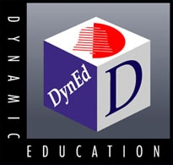

# Effective Language Study Cuts Aviation Training Costs

# A Case Study

Cadet pilots typically require a total of 250 hours of flight training to receive an FAA Commercial license. International students attending TransPac Aviation Academy in the US were often exceeding their programmed training hours due primarily to their lack of English skills. Training scenarios frequently had to be repeated due to poor English communication between cadets and instructors, cadets and air traffic controllers, etc. These extra hours of flight training translated into substantial Overage Costs for Transpac Aviation Academy.

In a study with 3 different airlines that consistently had high overage costs, Transpac used DynEd’s Aviation English program for 3 months before the cadets’ arrival in the US, and again during their on-site training in the US.

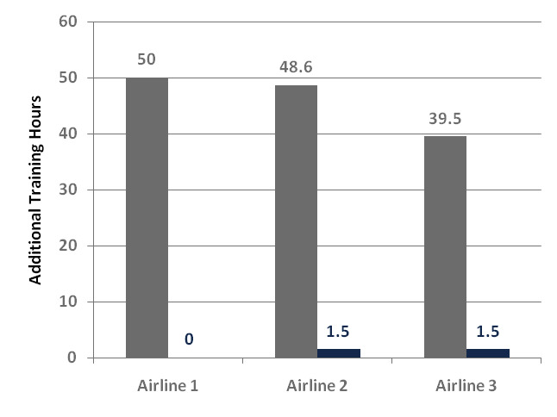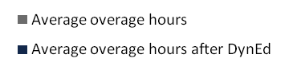

As the figure shows, with the DynEd training cadets from all three airlines successfully completed their flight training *with few or no additional training hours*, a significant reduction from the average of 46 overage hours without the training. This translated into a savings of over $9,500 per cadet in flight training hours alone. When other factors such as living costs are added in, the savings was much greater.

**Lance Knowles, President and Head of Courseware Development**

**DynEd International (www.dyned.com)**

Mr Knowles has pioneered the development and use of CALL for more than 25 years. His innovative learning theory, RHR, is based on neuroscience, and his award-winning programs are used by students in over 70 countries.

For more information please contact DynEd´s Country Management Partner for the Czech Republic, at [www.dyned.cz](http://www.dyned.cz) or phone +420 222 317 101.