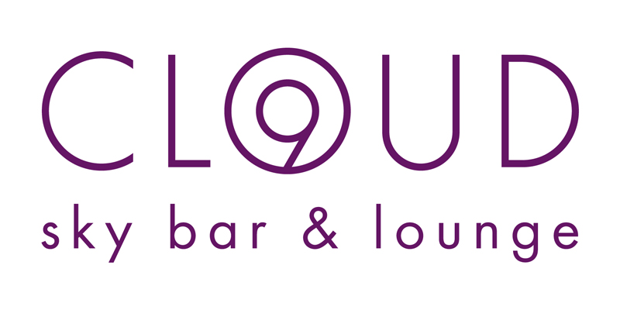

CONTACT:
Markéta Šebková
+420 224 842 711
marketa.sebkova@hilton.com

Cloud 9 Barmen’s Race

PRAGUE, Czech Republic – May 22, 2013 - As part of the Volkswagen-Marathon program, Hilton Hotels in Prague had organized the traditional Cloud 9 Barmen´s Race that took place on Saturday May 11 at 2 pm. For the first time, it was located in front of the Sport Expo at the Exhibition Grounds in Prague- Holešovice, instead of the original location at the Old Town Square. Cloud 9 was presented with a large chill out zone.

The Cloud 9 Barmen´s race was part of a whole day program, which took place in the Cloud 9 chill out zone from 10 am to 6 pm and was moderated by Iva Vavřínová and Lucie Šilhánová. Highlights of the day included show races with the famous bartender and mixologist Roman Uhlíř against visitors and the race itself, which started at 2 pm.

Throughout the day visitors had a chance to test the race track on their own, while listening to the music of a DJ and tasting three non-alcoholic cocktails - Marathon Runner, Virgin Extravaganza and Virgin Desire. All this took place at the Cloud 9 chill out zone with a total area of almost 600m² and a comfortable seating for up to 50 people.

Originally the Cloud 9 Barmen´s race was introduced as a side event of the Volkswagen-Marathon and was always a funny, but competitive running race. This year the race was moved for the first time to the area in front of the Sport Expo at the Exhibition Grounds in Prague - Holešovice to gain more space and was organized on a different day than the main race to attract an even larger audience.

Seven teams of three people participated in the Cloud 9 Barmen’s Race, which were representing different Prague bars. Even though the weather conditions were not the best, the teams showed a hard but fair competition. The goal of this fun race was to carry a drink on a tray without spilling too much of it while running through a course with different obstacles. A jury had overseen the race and had decided about the winning team depending not only on the fastest time but also on the amount of liquids spilled. The winner of the Cloud 9 Barmen’s Race this year was the team of La Casa de la Havana Vieja bar.

Prices were sponsored by the Hilton Hotels in Prague as well as Cloud 9 sky bar & lounge and included such treats as a Cloud 9 exclusive party for six persons with unlimited consumption of nine signature cocktails or vouchers for free consumption in Cloud 9.

About Cloud 9 sky bar & lounge:
Cloud 9 sky bar & lounge on the rooftop of the Hilton Prague is the first true sky bar in Prague. With a bespoke lighting system and a unique interior, the bar is perfectly designed for every guest of to enjoy captivating views over the city from the height of 40 meters above the river Vltava, both from behind the all-glass walls or from the outside terrace. Original signature cocktails are created by Roman Uhlir, one of the best Czech bartenders and mixologists. Cloud 9 visitors can take advantage of a special offer - Cloud 9 tasting, which includes unlimited consumption of the signature cocktails for only 490 CZK per person from 6 pm to
9 pm, Monday to Saturday.
www.cloud9.cz

Hilton Hotels in Prague have been a proud partner of the Prague International Marathon already for 18 years. Hilton Worldwide operates two properties in Prague, Hilton Prague & Hilton Prague Old Town.

