**Jaromir Jagr Hosts, Visits With Children of Boston First Responders After Game 2 in Boston (Photo) by NESN Staff on Wed, May 22, 2013 at 10:07AM**

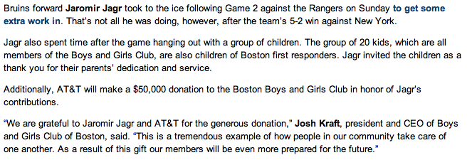

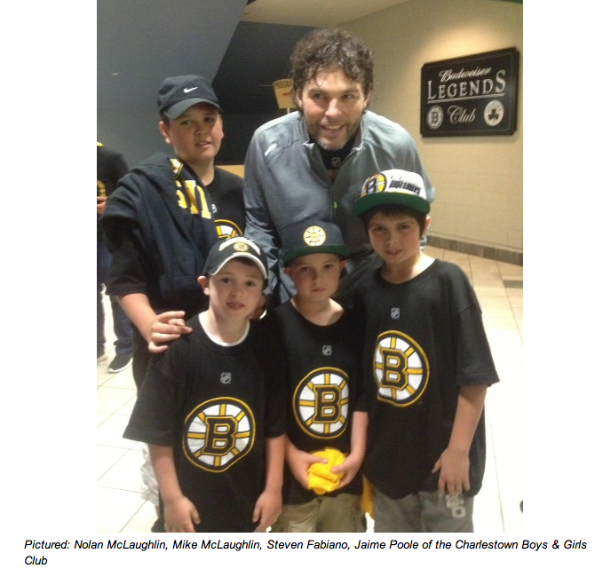

**Source:** [**NESN.com**](http://NESN.com)