International Personal Finance plc
Annual results announcement and statement of dividends
Year ended 31 December 2008

Praha, March 4, 2009

International Personal Finance plc, mother company of Provident Financial s.r.o. in Czech Republic and Slovakia, has announced its financial results for the year ended 31 December 2008.

In order to present the underlying performance variance, prior year figures are quoted at
constant exchange rates (CER).

Operating and financial highlights
􀂾 Profit before tax up by 40.3%* (4.3%* at CER) to £70.3 million (2007: £50.1 million∗)
􀂾 Earnings per share up by 44.5%* (7.5%* at CER) to 19.73 pence
􀂾 Central Europe profit before tax up 31.5%* (7.4%* at CER) to £106.0 million
􀂾 Mexico on track for 2009 profit
􀂾 Strong balance sheet with equity at 45.1% of receivables
􀂾 Core funding in place to October 2011
􀂾 Proposed final dividend increased by 19.3% to 3.40 pence per share (full year dividend:
5.70 pence)

Chief Executive Officer, John Harnett, commented: “This has been another successful year, with good progress made towards our strategic objectives: We passed our £95 million profit target for Central Europe a year ahead of schedule and Mexico remains on track to report a profit for 2009 and Romania for 2010. We also succeeded in extending our core bank facilities through to October 2011. Looking forward we have a strong balance sheet and a resilient business model. We are well placed to weather the downturn, and to respond rapidly and grow when conditions improve.”

∗ 2007 results and % growth stated on a pro forma basis

Summary

Profit before taxation for the year ended 31 December 2008 increased by 40.3% to £70.3 million
and earnings per share increased by 44.5% to 19.73 pence
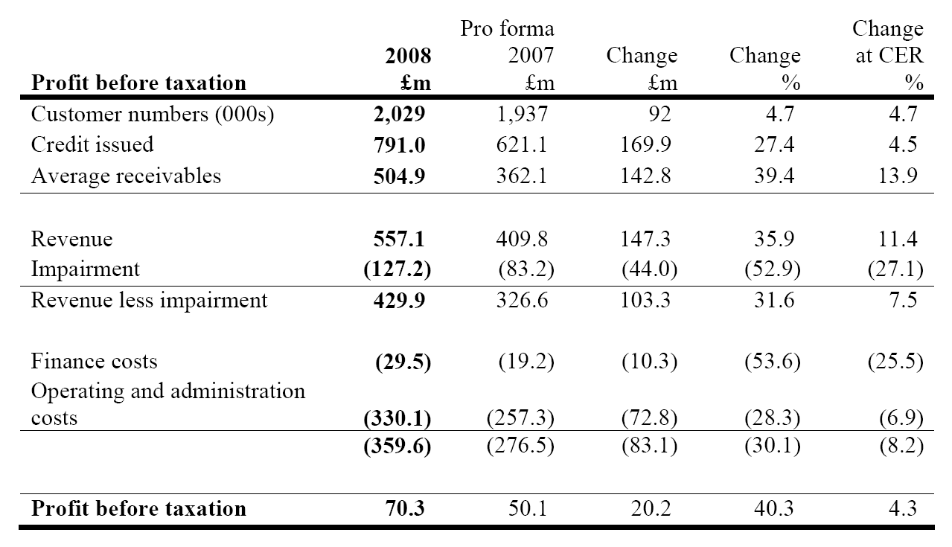

During the year the business made good progress towards its strategic objectives: In Central
Europe we surpassed the £95 million profit target set at demerger, earning a profit before tax
from these markets of £106 million; Our developing markets in Mexico and Romania progressed
to plan. Our entry into Russia was successfully achieved.

The global economic climate deteriorated rapidly during 2008. We decided to act early and so substantially tightened our credit controls in Central Europe in October 2008, focusing on lower risk lending and so slowing the intake of new customers and the volume of repeat lending to existing customers. We also decided to defer further new country entry and reduced to a minimum growth in headcount, capital expenditure and costs.

Group customer numbers increased by 4.7% in the year and now stand at over 2 million. The
growth in customer numbers came from the developing markets of Romania and Mexico with
customer numbers in Central Europe reducing slightly as a result of the impact of the credit
tightening. Credit issued increased by 4.5% to £791.0 million.

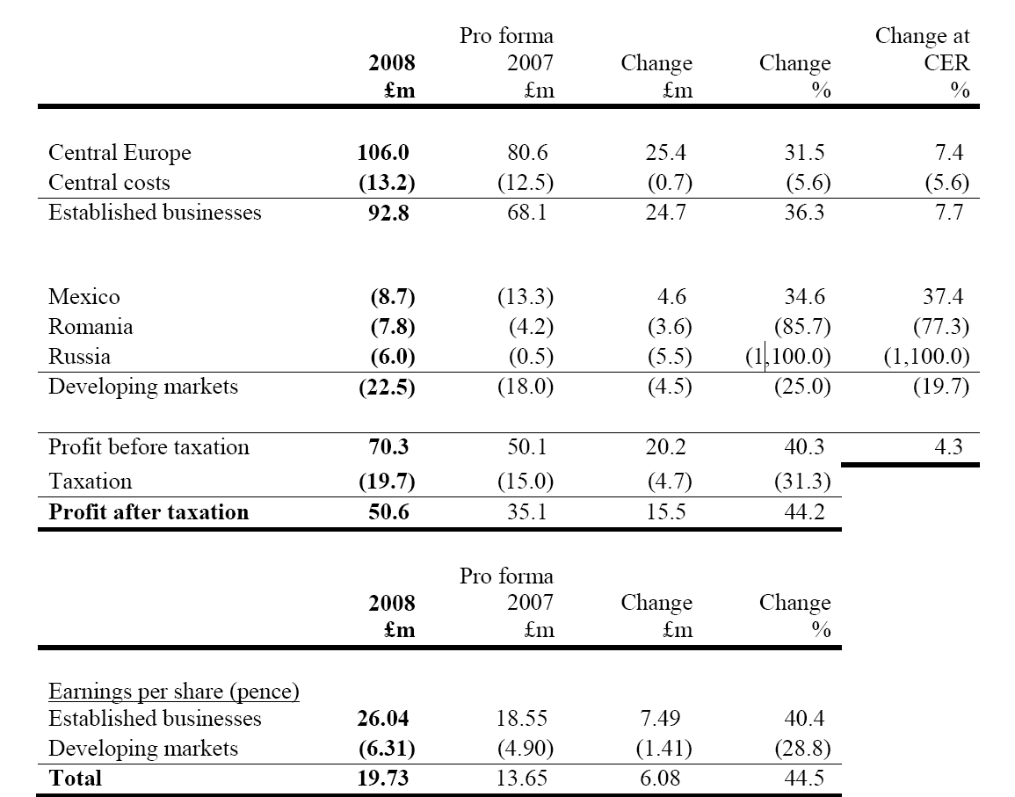

Central Europe

Our established Central Europe business reported pre-tax profits of £106.0 million, an increase of
£25.4 million (31.5%) on the prior year. This reflects a good performance in the year but also the
strength of the Central European currencies, which meant that the rates used to retranslate profits
were approximately 23% better than 2007. Excluding exchange rate movements but including the
negative short-term impact of the credit tightening, profits increased by 7.4%.

Central Europe performed well in 2008, with reported pre-tax profits of £106.0 million, up by
31.5% from 2007.

Czech Republic and Slovakia

Growth in these markets was also impacted by the credit tightening. Customer numbers reduced
by 1.2% and credit issued by 0.2%. Average net receivables increased by 6.0% leading to an
increase in revenue of 5.0% to £130.5 million.
Impairment as a percentage of revenue increased to 24.5% from 21.2%, partly as a result of the
strong growth in credit issued in the first three quarters of 2008, and partly due to lower revenue
as a result of the credit tightening.

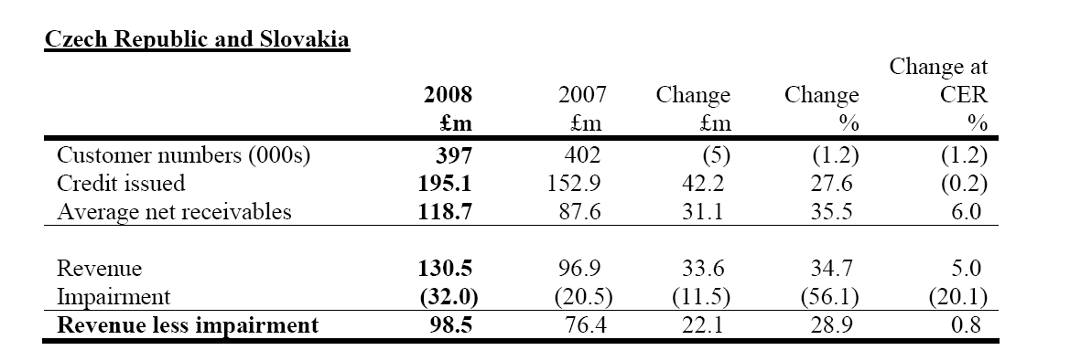

Complete report with IPF financial results for the zdar ended 31 December 2008 is available at: http://www.ipfin.co.uk/downloads/view/83

Contacts for editors:

John Mitra
Head of Marketing and Communication
T: +44 (0)113 285 6784
Mobile: +44 (0)7739 702230
John.Mitra@ipfin.co.uk

Victoria Richmond
International Communications Manager
T: +44 (0)113 2856873
Mobile: +44 (0) 7979414414
Victoria.richmond@ipfin.co.uk

