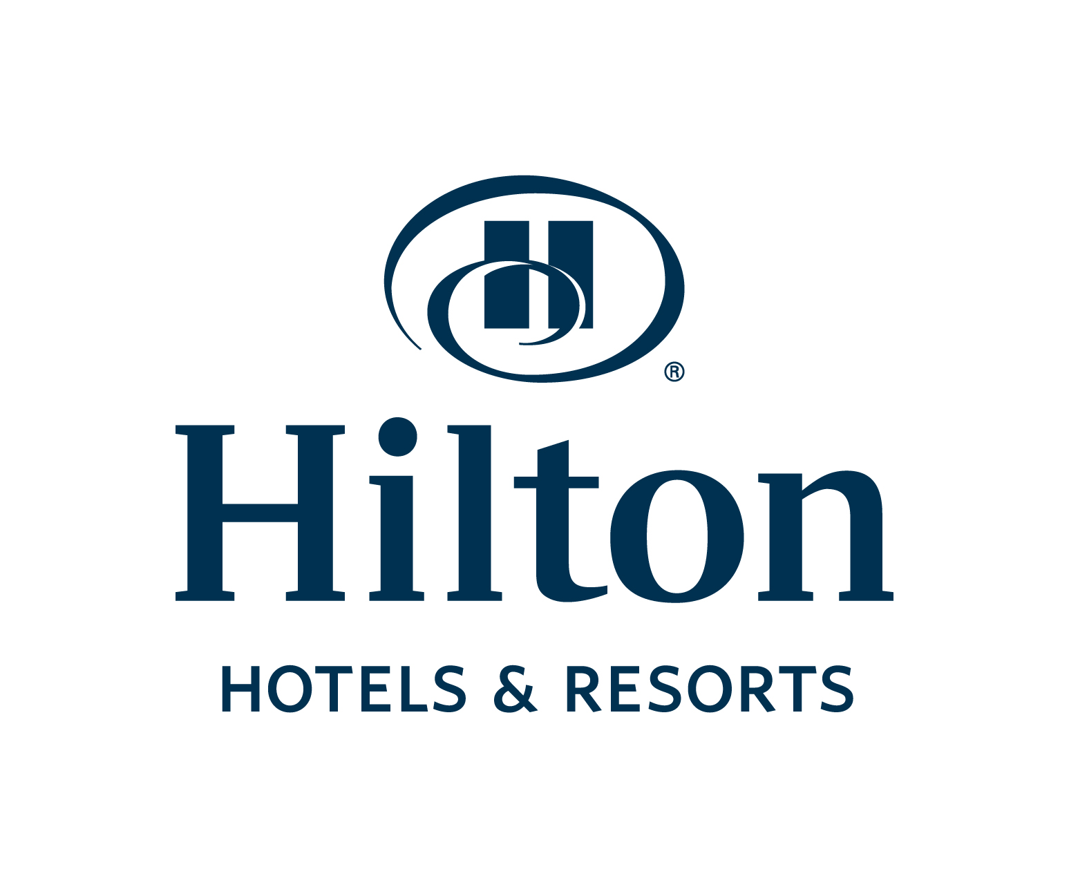

CONTACT:
Marketa Sebkova
Hilton Prague & Hilton Prague Old Town
+420 224 842 711
marketa.sebkova@hilton.com

Hilton hotels in Prague donated 53 500 CZK to support training of an assistance dog for small Jakub
PRAGUE – 11th September, 2013 – Hilton Hotels in Prague donated 53 500 CZK to support training of an assistance dog for a five-year-old Jakub Vykysela, who suffers from polio. Michael Specking, General Manager of Hilton Hotels in Prague, handed over a cheque to the family of Jakub in presence of representatives of Hilton Hotels in Prague and “Pestrá společnost“ organization that train assistance dogs .
Hilton Hotels in Prague have been financially supporting training of the assistance dog Bentley who will assist Jakub in everyday tasks, help him with exercises and an intensive rehabilitation that will contribute to his independency. During the cheque handover ceremony, Bentley and Jakub presented the audience what they have learnt so far together.
The training of an assistance dog costs around 180 000 CZK. Hilton Hotels in Prague have raised in total the amount of 103 500 CZK, which was donated to Jakub’s family in two instalments. The money raised come from the proceeds of a „Small Change, Big Difference” campaign that invites guests staying at Hilton Worldwide hotels to add an optional 1 Euro onto their room bill during their stay. Since its inception in 2004, the campaign has already raised 1.33 million Euro for children’s charities.
-###-

About Pestrá společnost
A public service company Pestrá společnost was founded in 2009 by a number of people with a common interest in cynology and social field activities. The mission of the company is a qualitative training of assistance dogs for people with disabilities, active employment of people with disabilities, educational programs for schools and general public, projects focusing on leisure activities for disadvantaged people and their implementation and cynology consulting.

About Hilton Worldwide
Hilton Worldwide is a leading global hospitality company, spanning the lodging sector from luxurious full-service hotels and resorts to extended-stay suites and mid-priced hotels. For 94 years, Hilton Worldwide has offered business and leisure travellers the finest in accommodations, service, amenities and value. The company is dedicated to continuing its tradition of providing exceptional guest experiences across its global brands. Its brands are comprised of more than 4,000 hotels and timeshare properties, with more than 650,000 rooms in 90 countries and territories and include Waldorf Astoria Hotels & Resorts, Conrad Hotels & Resorts, Hilton Hotels & Resorts, DoubleTree by Hilton, Embassy Suites Hotels, Hilton Garden Inn, Hampton Hotels, Homewood Suites by Hilton, Home2 Suites by Hilton and Hilton Grand Vacations. The company also manages the world-class guest reward program Hilton HHonors®. Visit www.hiltonworldwide.com for more information and connect with Hilton Worldwide at www.facebook.com/hiltonworldwide, www.twitter.com/hiltonworldwide, www.youtube.com/hiltonworldwide, www.flickr.com/hiltonworldwide and www.linkedin.com/company/hilton-worldwide

